**Alleged meth kingpin Tse Chi Lop extradited to Australia**

By Joshua Berlinger, CNN

 3 min read

Updated 5:34 PM EST, Wed December 21, 2022

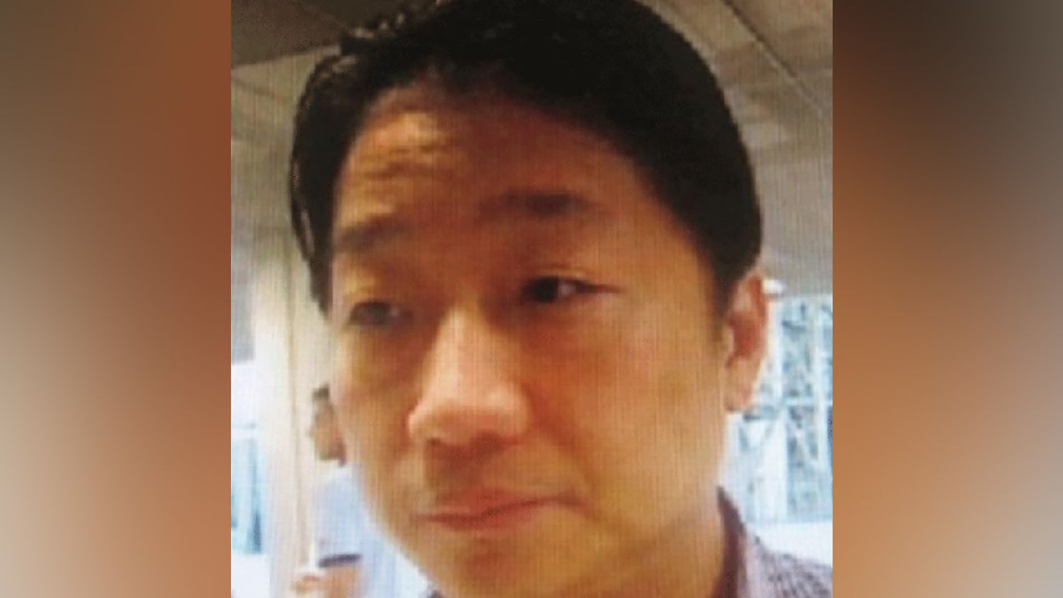

Tse Chi Lop, a Canadian national, is facing charges in Australia.

**CNN —**

[Tse Chi Lop](http://www.cnn.com/2021/09/06/asia/tse-chi-lop-sunblock-intl-hnk-dst/index.html), an alleged drug kingpin accused of running a multibillion dollar methamphetamine empire, has been extradited to Australia following a nearly two-year legal battle with Dutch authorities.

Tse, 59, was arrested in [January 2021](https://www.cnn.com/2021/01/23/asia/tse-chi-lop-arrest-intl-hnk/index.html)after he landed at Amsterdam’s Schipol International Airport on a flight from the Taiwan. Dutch authorities then detained him on a warrant from the Australian Federal Police (AFP) issued in 2019 in connection with an operation targeting Sam Gor, the drug-trafficking syndicate he is accused of heading.

Through his lawyers, Tse has denied all the allegations Australian authorities have leveled against him.

Australian authorities said Tse arrived Thursday and was formally charged shortly after landing.

Tse, a Chinese-Canadian dual national, decided to stop the appeals process in November, after months of fighting extradition, an attorney representing him told CNN. [Tse’s lawyers had argued](https://www.cnn.com/2021/06/22/europe/tse-chi-lop-extradition-intl-hnk/index.html)that he was illegally sent to the Netherlands – where extradition laws are more favorable than much of the world – as part of a scheme to ensure he stays behind bars for as long as possible.

Andre Seebregts, one of Tse’s attorneys, said his client was put on the plane to the Netherlands against his will and in violation of Taiwanese law, which required the island’s authorities to deport him to his home country, Canada, unless he agreed otherwise. Seebregts told CNN that there was a direct flight to Canada less than an hour before Tse’s plane took off at about 1 a.m.

Australian police declined to comment at the time.

[[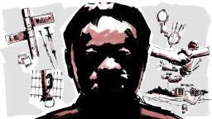](https://edition.cnn.com/2021/09/06/asia/tse-chi-lop-sunblock-intl-hnk-dst/index.html)](https://edition.cnn.com/2021/09/06/asia/tse-chi-lop-sunblock-intl-hnk-dst/index.html)

**[Related article](https://edition.cnn.com/2021/09/06/asia/tse-chi-lop-sunblock-intl-hnk-dst/index.html)**[Demise of a kingpin, rise of an empire](https://edition.cnn.com/2021/09/06/asia/tse-chi-lop-sunblock-intl-hnk-dst/index.html)

Asia’s methamphetamine trade is believed to be worth billions of dollars each year and Sam Gor, which is sometimes simply referred to as “The Company,” is allegedly its biggest player.

Authorities alleged that the organization was, as of 2018, earning between $8 billion and $17.7 billion worth of illicit proceeds a year, [according to a briefing on the syndicate shared with CNN by an official with direct knowledge of the investigation](https://www.cnn.com/2021/01/23/asia/tse-chi-lop-arrest-intl-hnk/index.html).

The organization is accused of running a synthetic drug manufacturing empire in large swathes of the under-policed jungles of Myanmar, a region marred by civil war and still under the control of various competing warlords and militias – conditions that make it easy to hide industrial-scale drug manufacturing operations from law enforcement.

Tse allegedly ran his multibillion dollar operation from Hong Kong, Macao and southeast Asia. But his name – or existence – was not public knowledge until he was revealed by a Reuters investigation published in 2019 that dubbed him “Asia’s El Chapo.”

His arrest, however, has not stopped the massive flow of drugs in Southeast Asia. A record amount of methamphetamine – including 1 billion meth tablets – [was seized in 2021](https://www.unodc.org/roseap/en/2022/05/regional-synthetic-drugs-report-launch/story.html), and drug prices remain cheaper than ever, according to the United Nations Office on Drugs and Crime.

Tse has faced criminal narcotics charges before. He pleaded guilty to conspiracy to import heroin into the United States and was sentenced to nine years in prison in 2000. He was released in 2006 and returned to Canada before moving to Hong Kong